#include <LiquidCrystal.h>

LiquidCrystal lcd(12, 11, 5, 4, 3, 2);

int V_GasSen = 0;
float V_TempSens = 0;

int gasSensor = A0;
int tempSensor = A1;

int buzzer = 7;
int gasLED = 9;
int tempLED = 10;

void setup()
{
pinMode(gasSensor, INPUT);
pinMode(tempSensor, INPUT);

pinMode(buzzer, OUTPUT);
pinMode(gasLED, OUTPUT);
pinMode(tempLED, OUTPUT);

lcd.begin(16, 2);

Serial.begin(9600);

lcd.print("System Starting");
delay(2000);
lcd.clear();
}

void loop()
{
V_GasSen = analogRead(gasSensor);

int tempReading = analogRead(tempSensor);

float voltage = tempReading * 5.0 / 1023.0;

V_TempSens = (voltage - 0.5) * 100.0;

Serial.print("Gas Value: ");
Serial.println(V_GasSen);

Serial.print("Temperature: ");
Serial.println(V_TempSens);

lcd.clear();

lcd.setCursor(0, 0);
lcd.print("Temp: ");
lcd.print(V_TempSens, 1);
lcd.print(" C");

lcd.setCursor(0, 1);
lcd.print("Gas: ");
lcd.print(V_GasSen);

if (V_GasSen >= 250)
{
digitalWrite(gasLED, HIGH);
tone(buzzer, 523);

lcd.clear();
lcd.setCursor(0, 0);
lcd.print("GAS DETECTED!");
lcd.setCursor(0, 1);
lcd.print("Check Leakage");
}
else if (V_TempSens >= 70)
{
digitalWrite(tempLED, HIGH);
tone(buzzer, 523);

lcd.clear();
lcd.setCursor(0, 0);
lcd.print("HIGH TEMP!");
lcd.setCursor(0, 1);
lcd.print("Temperature Alert");
}
else
{
digitalWrite(gasLED, LOW);
digitalWrite(tempLED, LOW);
noTone(buzzer);
}

if (V_GasSen < 250)
{
digitalWrite(gasLED, LOW);
}

if (V_TempSens < 70)
{
digitalWrite(tempLED, LOW);
}

if (V_GasSen < 250 && V_TempSens < 70)
{
noTone(buzzer);
}

delay(1000);
}

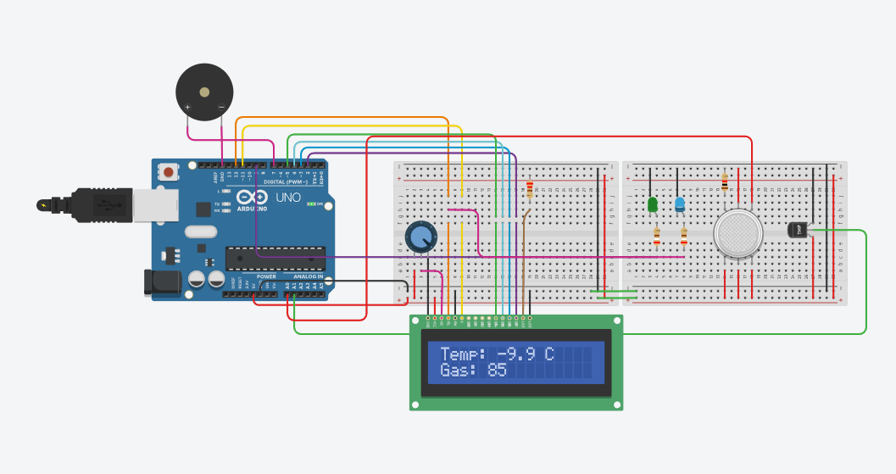

https://www.tinkercad.com/things/bXuMpUeV2S0-industrial-safety-monitoring-using-iot-

